Previous years jee problems and solutions

**1.Isomers of hexane, based on their branching, can be divided into three distinct classes as shown in the figure.**

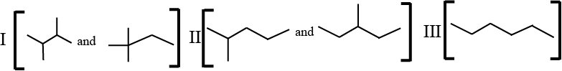

**The correct order of their boiling point is**

**A. I > II > III**

**B. II > III > I**

**C. III > II > I**

**D. III > I > II**

**Solution: (C)**

**More the branching in an alkane, lesser will be the surface area, lesser will be the boiling point as weaker will be the intermolecular attractive force**

**2. The bond energy (in kcal mol-1) of a C−C single bond is approximately:**

**A. 1**

**B. 10**

**C. 100**

**D. 1000**

**Solution: (C)**

C-C single bond dissociation energy range is between 88 to 150 Kcal mol1-1

C-C bond energy = 348J/mol = 348 / 4.2 kcal/mol

= 82.85 kcal/mol

≈ 100 kcal/mo

3**. The total number of stereoisomers that can exist for M is:**

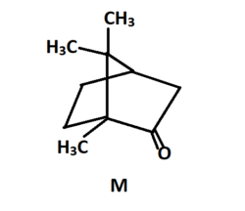

**Solution:** (2)

The total number of stereoisomers is 2.

This molecule can not show geometrical isomerism so only mirror image will be other stereoisomer.

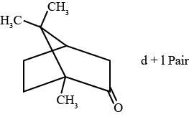

**4. The total number(s) of stable conformers with non-zero dipole moment for the following compound is (are):**

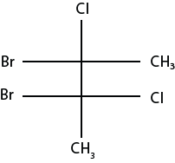

**A. 2**

**B. 4**

**C. 3**

**D. 5**

**Solution: (C)**

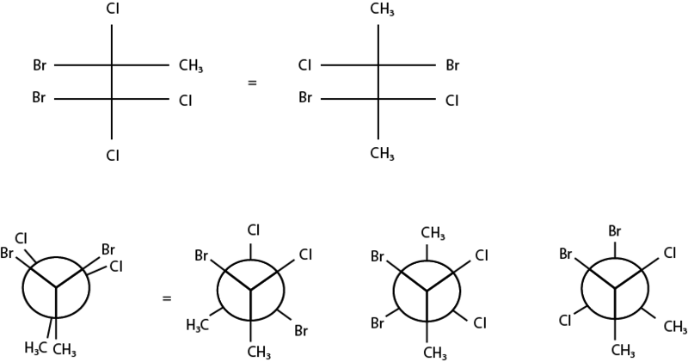

Three stable (staggered) conformers exist (with μ≠0)

**Note:** Two or more structures that are categorized as conformers differ only in terms of the angle about one or more sigma bonds.

**5. Newman projections P, Q, R and S are shown below:**

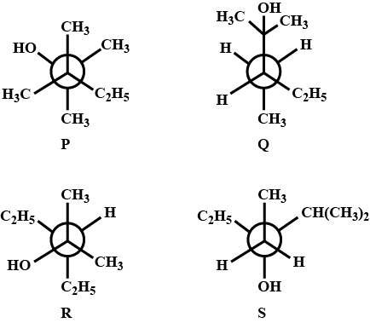

**Which one of the following options represents identical molecules?**

**A. P and Q**

**B. Q and S**

**C. Q and R**

**D. R and S**

**Solution:**(C)

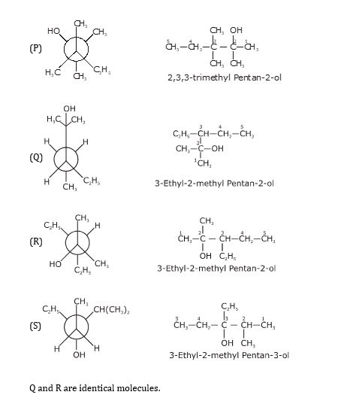

**6. On monochlorination of 2-methylbutane, the total number of chiral compounds obtained is.**

**A. 2**

**B. 4**

**C. 6**

**D. 8**

**Solution:**(A)

During the monochlorination of 2 methyl butane, four compounds are possible however only two of them will be chiral in nature. Here, I and III are chiral.

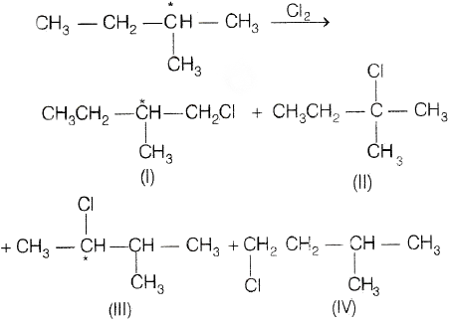

**7. Which of the following reaction produce propane as a major product?**

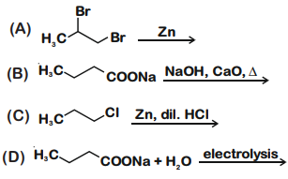

**Solution:**(B and C)

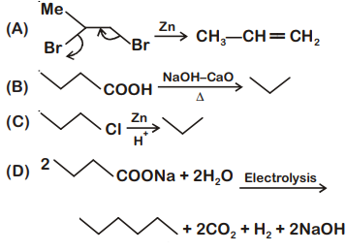

8**. The correct statement(s) for the following addition reactions is(are):**

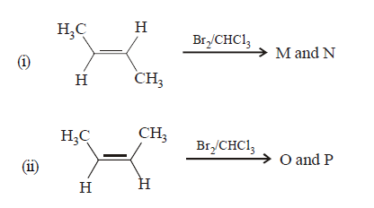

**A. O and P are identical molecules**

**B. (M and O) and (N and P) are two pairs of diastereomers**

**C. (M and O) and (N and P) are two pairs of enantiomers**

**D. Bromination proceeds through trans-addition in both the reactions**

**Solution:**(B and D)

(B) (M and O) and (N and P) are two pairs of diastereomers. They have the same configuration at one chiral carbon atom and a different configuration at other chiral carbon atoms.

(D) Bromination proceeds through trans-addition in both reactions. It involves the formation of cyclic bromonium ions.

